Sprint - 2 Deliverables

USN-3: Working with the datasets (Understanding and loading)

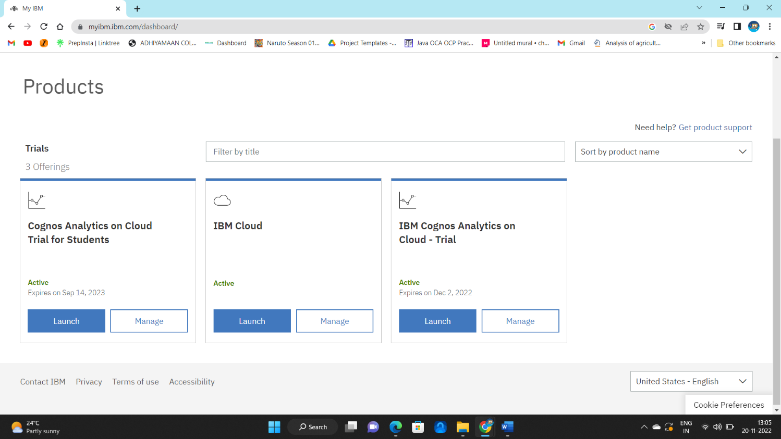

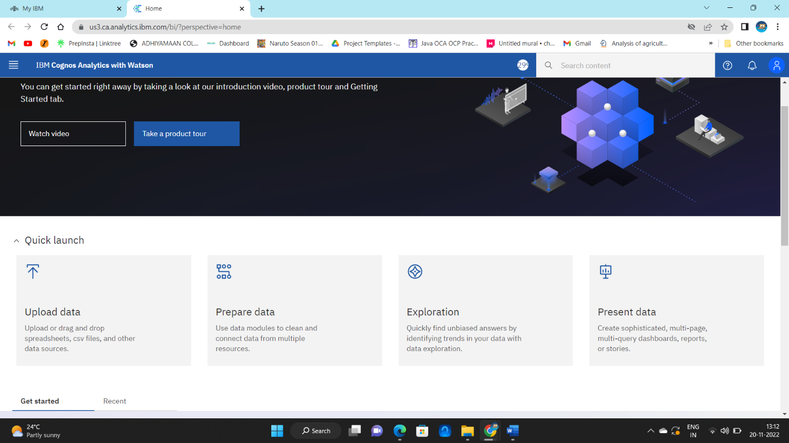

USN-4: Preparing the datasets and performing required calculations

